Exercise sheet 7

Exercise 7.1: Epistemic vs. Aleatoric Uncertainty
Define epistemic and aleatoric uncertainty.
1. Which type is more relevant to OOD inputs (e.g., night images for a model trained
on day images)?
Answer: Epistemic uncertainty.
Night images are outside the training distribution. The model has limited knowledge about such situations because it primarily learned from daytime images. Therefore the uncertainty comes from a lack of knowledge rather than inherent randomness.

2. Which type would you expect to be dominant in a correctly classified, in-distribution
image?
Answer: Aleatoric uncertainty.
For an in-distribution image, the model has already seen many similar examples during training, so epistemic uncertainty is low. Any remaining uncertainty is mainly due to irreducible noise such as image quality, sensor noise, or ambiguity in the scene.

Exercise 7.2: Calibration and ECE
Explain what it means for a classifier to be well-calibrated. Define the Expected Calibration Error (ECE) and describe how it is computed.
Answer
A classifier is well-calibrated when its predicted confidence matches its empirical accuracy. For example, among all predictions made with 80% confidence, approximately 80% should be correct. Expected Calibration Error (ECE) measures the difference between confidence and accuracy. To compute ECE, predictions are divided into confidence bins, the accuracy and average confidence are calculated for each bin, and the weighted average of the absolute differences between confidence and accuracy is computed. An ECE of 0 indicates perfect calibration, while larger ECE values indicate poorer calibration.

Exercise 7.3: Cost-Optimal Downstream Decisions
Answer
7.3.1
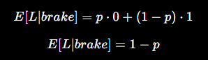
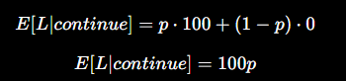
7.3.2

$$1=101p \\ p=\frac{1}{101} \\ τ^{*}=0.0099$$
7.3.3
τ∗ for the costs above is roughly $1\%$
A pedestrian collision is 100× more expensive than an unnecessary brake.
Therefore:
The system should brake even when the pedestrian probability is only about 1%.
This is much more conservative than the standard 50% threshold.

7.3.4
Cost-optimal decisions require calibrated probabilities. A poorly calibrated model can underestimate or overestimate risk, causing unsafe actions even when the theoretically optimal threshold is used.

Exercise 7.4: Measuring Calibration
1. Compute the ECE of each of your three trained CARLA models on the in-distribution test set.

2. Plot a reliability diagram (confidence vs. accuracy) for each model.
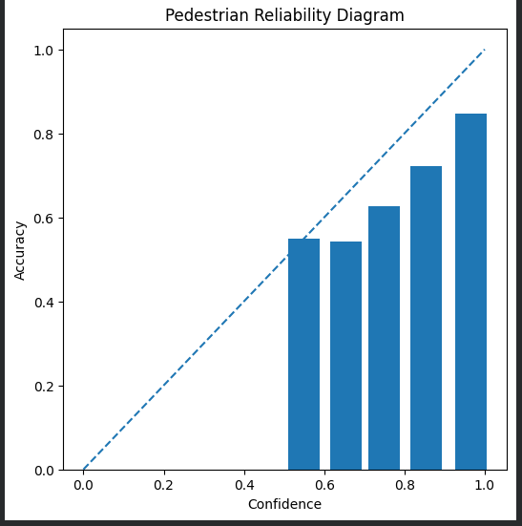
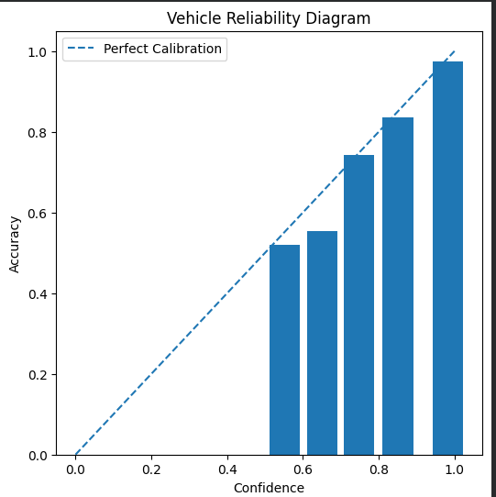
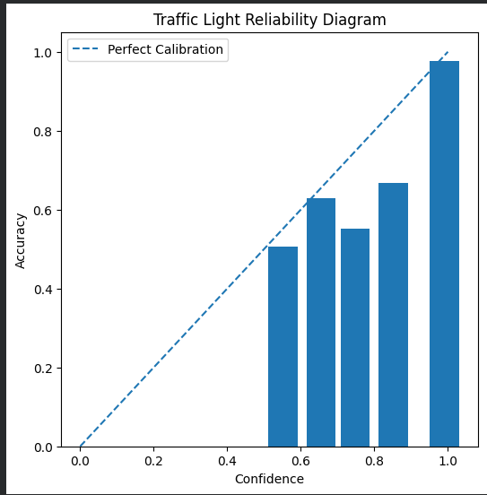

3. Are your models over- or underconfident? Does this pattern hold consistently across all three models?
Answer
The pedestrian classifier is overconfident. In most confidence bins, the empirical accuracy is lower than the predicted confidence. This is particularly visible in the high-confidence region, where confidence values close to 1.0 correspond to lower observed accuracies. The measured ECE of 0.108 further confirms the presence of calibration errors. Therefore, the classifier tends to overestimate the reliability of its predictions.

The vehicle classifier achieved an ECE of 0.015, indicating very good calibration. The reliability diagram shows that most confidence bins lie close to the ideal calibration line. Therefore, the confidence estimates produced by the vehicle classifier closely match the observed accuracy. Compared to the pedestrian classifier (ECE = 0.108), the vehicle model is substantially better calibrated and provides more reliable probability estimates.

The traffic-light classifier is well calibrated, although not quite as well calibrated as the vehicle classifier. The reliability diagram shows small deviations from the ideal calibration line, indicating minor overconfidence in some confidence ranges. However, the low ECE value of 0.029 confirms that the confidence estimates are generally reliable.

The vehicle classifier achieved the best calibration performance with an ECE of 0.015. The traffic-light classifier also demonstrated good calibration with an ECE of 0.029. The pedestrian classifier had the highest ECE (0.108), indicating noticeable overconfidence and poorer calibration. Overall, the vehicle and traffic-light models produce more reliable confidence estimates than the pedestrian model.

Exercise 7.5: Temperature Scaling
1. Apply temperature scaling to each of your three models. Optimize T on the validation
set using negative log-likelihood.
2. Report the ECE before and after scaling for each model.

Model | Best T | ECE Before | ECE After
Pedestrian | 2.4 | 0.1077 | 0.0362
Vehicle | 1.3 | 0.0154 | 0.0155
Traffic Light | 1.1 | 0.0294 | 0.0253

Temperature scaling was applied by fitting a single temperature parameter T on the validation set using NLL minimization. The pedestrian classifier required the largest correction (T = 2.4), reducing ECE from 0.108 to 0.036. This indicates that the model was substantially overconfident before calibration. The vehicle classifier required only a small correction (T = 1.3), and its ECE remained essentially unchanged (0.015 before vs. 0.016 after), indicating that it was already well calibrated. The traffic-light classifier required a temperature of T = 1.1 and achieved a modest reduction in ECE from 0.029 to 0.025. Overall, temperature scaling was most beneficial for the pedestrian classifier and had only minor effects on the already well-calibrated vehicle and traffic-light classifiers.

Exercise 7.6: Cost-Optimal Decision in Practice
Use the costs from Exercise 3 (CFN = 100, CFP = 1, τ∗ ≈ 0.0099, i.e. a predicted probability
of roughly 1%) and apply them to your pedestrian classifier.
1. On the in-distribution test set, compute the total loss
L =CFN·#FN+CFP·#FP
for your uncalibrated model at both τ = 0.5 and τ = τ∗

2. Repeat for your temperature-scaled model at both thresholds.

3. Arrange the four results in a 2 × 2 table (rows: uncalibrated / calibrated; columns:
τ =0.5 / τ =τ∗). Which combination gives the lowest total loss?
Answer

Model | τ = 0.5 | τ = 0.0099
Uncalibrated | 26935 | 3962
Temperature-Scaled (T=2.4) | 26935 | 2894

Using the standard threshold ($τ=0.5$) produced the highest loss because many pedestrians were missed, resulting in costly false negatives. Applying the cost-optimal threshold ($τ^{*}=0.0099$) dramatically reduced the loss by prioritizing pedestrian detection. Temperature scaling further improved performance at the cost-optimal threshold by eliminating all remaining false negatives. The lowest total loss (2894) was achieved using the temperature-scaled pedestrian classifier with $τ^{*}=0.0099$.

Exercise 7.7: Tracing Overconfidence Through the Safety Analysis
You have now measured how miscalibrated confidence propagates silently to downstream
decisions. In STPA, an overconfident misclassification is a causal factor: a mechanism
that explains why an existing unsafe control action occurs. The goal of this exercise is to
add it as a loss scenario and trace it through to a verifiable constraint.

1.
UCA | Causal Scenario | Root Cause | Related Constraint
UCA-9 | The planner does not brake because the pedestrian classifier predicts "no pedestrian" with high confidence, causing the planner to continue driving without triggering a fallback mechanism. | Overconfident false-negative prediction caused by model miscalibration. | The pedestrian classifier shall maintain calibration quality (ECE ≤ 0.05) and high-confidence pedestrian absence predictions shall not be used without calibration verification.

2.
UCA | Safety Constraint | Level | Verification
UCA-9 | The pedestrian classifier shall maintain calibration quality (ECE ≤ 0.05) and high-confidence pedestrian absence predictions shall not be used without calibration verification. | Model-level | ECE evaluation before and after temperature scaling on validation/test sets

UCA | Safety Constraint | Level | Verification
UCA-10 | The planner shall use the cost-optimal pedestrian detection threshold (τ=0.0099) and initiate a conservative fallback action (e.g., braking or speed reduction) when pedestrian detection confidence is low or uncertain. | System-level | Cost-based evaluation and scenario testing on the pedestrian test set

3.
The proposed model-level calibration constraint was verified using Expected Calibration Error (ECE). The pedestrian classifier achieved an ECE of 0.1077 before calibration and 0.0362 after temperature scaling. Since the calibrated model satisfies the proposed threshold of ECE ≤ 0.05, the constraint is considered satisfied after calibration.

4.
Calibration reduces overconfidence but does not eliminate all classification errors. Even a calibrated classifier can produce false negatives due to occlusions, adverse weather conditions, sensor noise, distribution shifts, or adversarial perturbations. Therefore, calibration alone is insufficient to eliminate the unsafe control action. System-level measures such as confidence-based fallback behaviour, conservative thresholds (τ*=0.0099), and emergency braking mechanisms remain necessary.

